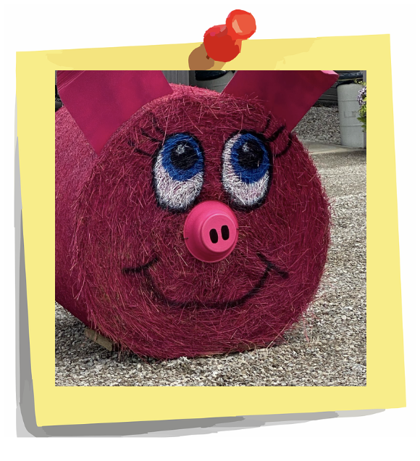
Theme: Farm Fun
We welcome you, your company, or organization to create a masterpiece showing off your hay bale decorating skills. Bales to be displayed and viewed by thousands visiting the Franklin County Fair in Hilliard, Ohio July 17-23, 2023.
- Hay bales will be displayed for the duration of the fair
- The Franklin County Agricultural Society will place a sign by your bale with your name for advertising opportunity
- Hay bales are proven to be a photo opportunity for visitors
- Entries will be highlighted in social media
- Compete with others to win
Sign up soon as the spots are limited!

REGISTRATION FORM
______________________________________________________________
NAME as used for promotional purposes
(Print Clearly)

Contact Name: ________________________________________________________________
Mailing Address:________________________________________________________________
Contact’s Phone #:____________________ Email address:_____________________________
Please indicate if you like your bale to be placed vertically or horizontally?

Vertical
Horizontal

Send registration with $100 entry fee to:
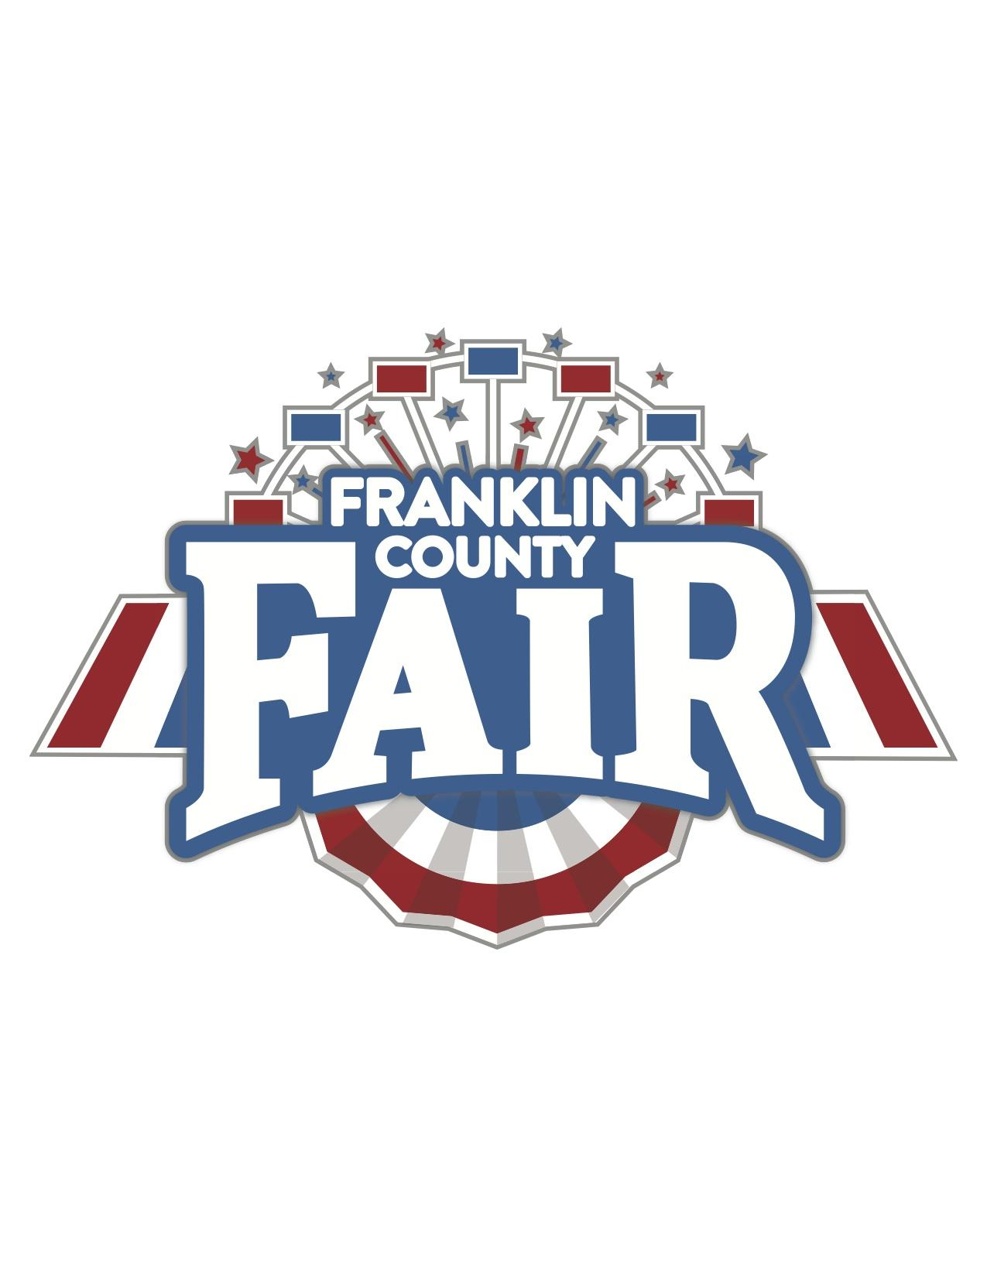
Franklin County Agricultural Society
PO Box 6
Hilliard OH 43026
Make checks payable to: FCAS
- or -
Email form to entertainment@fcfair.org and
call the fair office at 614-876-7235 to pay by credit card
Rules
- Each entry will automatically be entered into two competitions
  - Franklin County Fair’s Blue-Ribbon Bale
    - Bale to be judged July 17, 2023 by originality, creativity, good use of space, and keeping with the theme.
    - Winner to be announced during opening ceremonies, Monday, July 17, 2023.
    - Winning entry will receive social media recognition, return of entry fee, and invitation to the Friends of the Fair luncheon July 20, 2023.
  - People’s Choice Award
    - Voting open to fairgoers July 17, 2023 through Saturday July 22, 2023. Winner to be announced in the Burke Building in advance of the livestock auction, Sunday July 23, 2023.
    - Winning entry will receive social media recognition, return of entry fee, and invitation to the Franklin County Agricultural Society dinner November 9, 2023.
- Pre-registration required. Registration is not complete until both form and payment are received.
- Bales will be assigned on a first-come, first-served basis.
- Bales will be provided and placed throughout the fairgrounds at the sole discretion of the Senior Fair Board. Once set, bales may not be moved.
- An email will be sent in advance regarding the location of your bale.
- Decorators may access their bales from July 13, 2023 and must be finished no later than end of day on Saturday, July 15, 2023.
- Decorations should be weather and wind proof with bales stabilized to avoid tipping or rolling.
- No political, social, or controversial issues may be displayed.
- Decorators must provide their own decorating supplies. Spray paint may be used; limited to the bale (i.e. not on the grass or hard surface).
- No small sharp objects may be inserted into the bale (ex: staples, glass, etc).
- No mechanical, electrical or electronic devices may be used in the display.
- Please do not extend anything from the bale more than 3 feet.
- Anything deemed by the Senior Fair Board, in their sole discretion, to be unsafe or inappropriate in nature, will be removed.
- “Undecorating” of bales may begin at 8 pm on Sunday, July 23, 2023 with decorations to be removed by end of day on Monday, July 24, 2023. Any decorations not removed by July 24, 2023 will be discarded.
- The Franklin County Agricultural Society, its volunteers, directors, or agents are not responsible for lost, stolen, and/or damaged property.

For questions, contact entertainment@fcfair.org.

